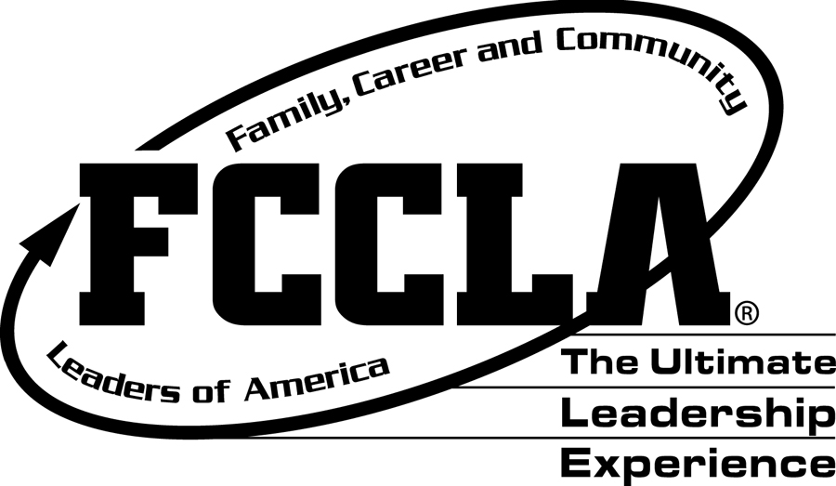
FCCLA Leadership Activities and Events
To improve your leadership skills and the leadership activities of our chapter, we have implemented a Leadership Grade that will be a part of the semester grade. This grade will be based on your attendance at specific leadership activities and your participation in the FCCLA organization.

There will be 100 points required per semester for the Leadership Grade. Students with the highest leadership points for the year will be acknowledged with a High Points award.
Leadership points are DUE MAY 17th!

The following are ways to earn points.

Event/Activity | Date | Points
Spring Fundraiser | TBA | 20
Chair Event | Ongoing | 20
Jr. High Tours | Jan. 9th, 10th, 11th | 25-75
January Chapter Meeting | January 23rd | 20
Returning Bear Night | January 16th | 30
8th Grade Orientation Night | January 23rd | 30
February FCCLA Week | 11th-15th | 10
February Community Service | TBA | 30
February Chapter Meeting | February 13th | 20
Spring Advisory Board | February 28th | 30-60
March District Competition | March 4th | 30
March Chapter Meeting | March 6th | 20
*Spring Competition** | April 15th – 17th | 100
April Chapter Meeting | April 24th | 20
May Chapter Meeting | May 15th | 20
May End of Year Banquet** (Tentative) | May 16th | 30
Volunteer Hours (5 points per hour) | Ongoing | 40
*Serve as an Officer (weekly meetings required) | Ongoing | 20
Student Choice | Ongoing | varies
Power of One | February 1st | 50
Total Points Required |  | 100

*Must have paid FCCLA dues to participate in these activities.
** Indicates there is a fee associated with this event/activity.

More information on the Career and Technical Student Organization, FCCLA (Family, Career, and Community Leaders of America) is available on the state and national websites.
State: http://www.azfccla.org/ArizonaFCCLA/Home.html
National: http://www.fcclainc.org/

